Chapter 4 Homework Problems

Problem 4.1

Determine if the two setups below are statically equivalent.

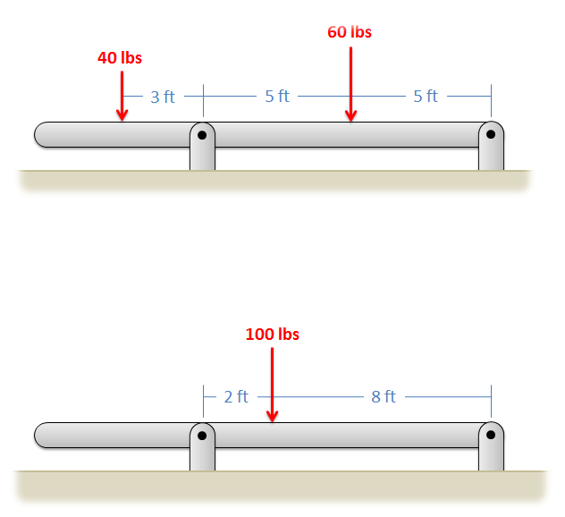

Solution: No, they are not equivalent.

Problem 4.2

Determine if the set of forces in A is statically equivalent to the set of forces and moments in B.

Solution: No, they are not equivalent.

Problem 4.3

Resolve the force shown below into a force and a couple acting at point A. Draw this force and couple on a diagram of the L shaped beam.

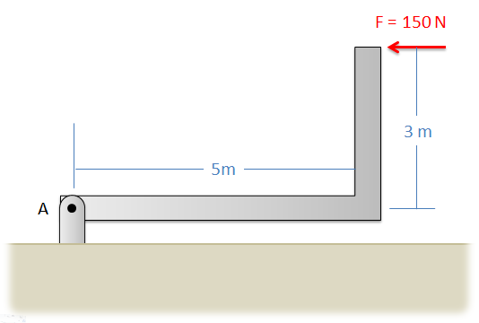

Solution: FA = 150 N to the left, MA = 450 Nm

Problem 4.4

Find the equivalent force couple system acting at A for the setup shown below. Draw this force and couple on a diagram of the L shaped beam.

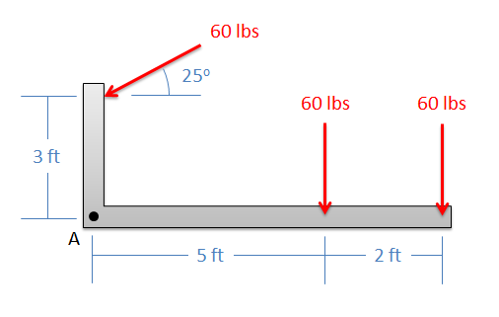

Solution: FA = 155.2 lbs 69.5o below the negative x axis, MA = -556.9 ft lbs

Problem 4.5

A helicopter is hovering with the wind force, the force from the tail rotor, and the moment due to drag shown below. Determine the equivalent force couple system at point C. Draw the final force and moment on a new diagram of the helicopter.

Solution: Feq = 858.01 N acting at 16.6o down from the negative x-axis, Meq = -250 Nm

Problem 4.6

Determine the equivalent point load (magnitude and location) for the distributed force shown below **using integration**.

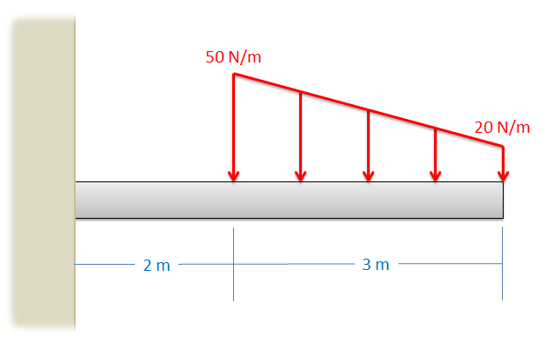

Solution: Feq = 105 N, xeq = 3.29 m

Problem 4.7

Determine the equivalent point load (magnitude and location) for the distributed force shown below **using integration**.

Solution: Feq = 5400 lbs, xeq = 8 ft (measured from wall)

Problem 4.8

Use the **method of composite parts** to determine the magnitude and location of the equivalent point load for the distributed force shown below.

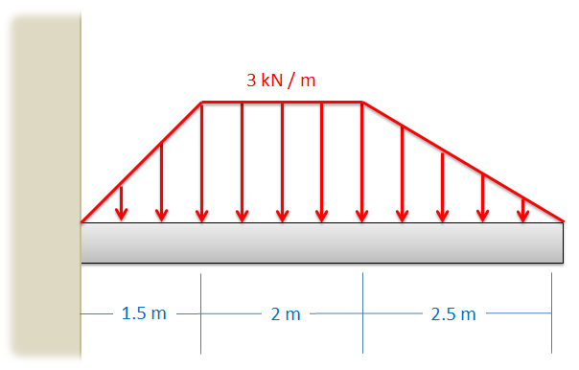

Solution: Feq = 12 kN, xeq = 2.79 m (measured from wall)